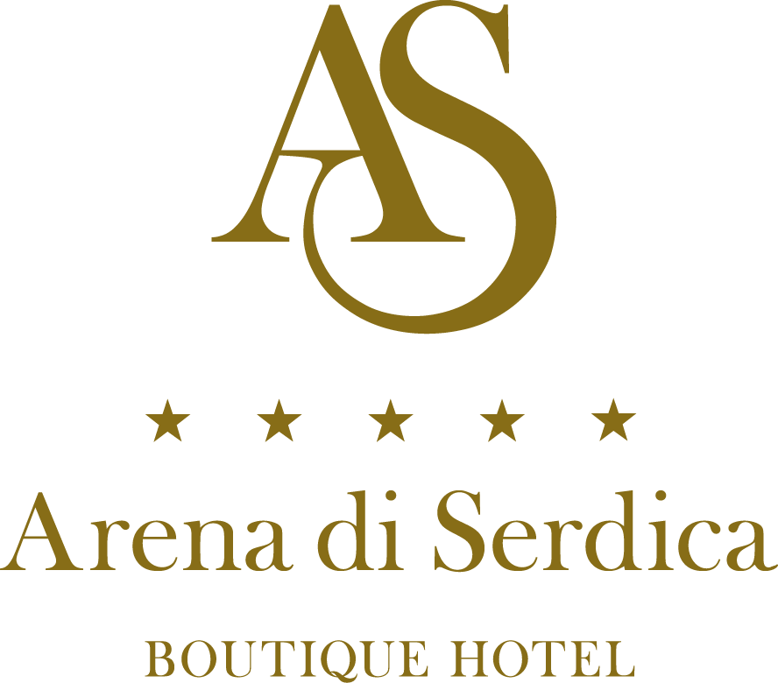

Anglo-American School Sofia

02-06 October 2019

Arena di Serdica Boutique Hotel
Sofia, Bulgaria

HOTEL RESERVATION FORM

Mr. □ Mrs. □ Ms. □ Name: __________________ Surname: ________________

Country code: _____ Tel: ____________ Fax: ___________ E-mail: ______________
- HOTEL RESERVATION

Tick the room type you require, indicate the total number of rooms and nights required.

Classic room
Single use □ 115.67 €
Double use □ 136.34 €

Executive room
Single use □ 135.67 €
Double use □ 156.34 €

Total No of nights: _________ No. of rooms: _________

Rates are per room, per night, inclusive of breakfast, internet access, fitness and 9% VAT and city tax of 0, 67 Euro.

Arrival: Departure:
Date: Date:

Please indicate the method of payment and guarantee reservation with credit card details:

Credit card name:_______________________ Number:________________________

Expiry date:___________________________ Signature:_______________________

2. TRANSFERS FROM / TO THE AIRPORT
Rate: EUR 20 /one way/
FROM the Airport: YES □ NO □
Flight number ________ Time of arrival: ________________

TO the Airport: YES □ NO □
Flight number ________ Time of departure: _____________

3. DEADLINE FOR RESERVATIONS

All reservations made after 6th of September, 2019 will be subject to availability.

4. CANCELLATION POLICY

Cancellation must be made in written. Any cancellation of reservation made three days or less prior arrival results in a charge of the first night accommodation fee.

PLEASE COMPLETE AND RETURN TO:

Arena di Serdica Residence Hotel
2-4, Budapeshta Str., Sofia 1000, Bulgaria
Tel. + 359 2 810 77 88
Fax + 359 2 810 77 70
e-mail: reservations@arenadiserdica.com
www.arenadiserdica.com

